Diamond Light Source Ltd



Rutherford Appleton Laboratory

Chilton, Didcot

Oxfordshire OX11 0QX

United Kingdom

[www.diamond.ac.uk](http://www.diamond.ac.uk)

Front End 10B Vacuum Control System Functional Specification

Prepared by: Hugo Shiers

Document Change Record

|  |  |  |  |
| --- | --- | --- | --- |
| Issue | Date | Section / Sheet | Comment |
| 1 | 3-May-19 | All | First working draft for review |
|  |  |  |  |
|  |  |  |  |
|  |  |  |  |
|  |  |  |  |
|  |  |  |  |
|  |  |  |  |
|  |  |  |  |
|  |  |  |  |
|  |  |  |  |
|  |  |  |  |
|  |  |  |  |
|  |  |  |  |
|  |  |  |  |

Contents

1 Introduction 4

2 Equipment to Control 4

2.1 Valves 4

2.2 Vacuum Gauges 5

2.3 Ion Pumps 5

2.4 Titanium Sublimation Pumps 6

2.5 Mechanical Pumps 6

3 External interfaces 6

3.1 RGA 6

3.2 storage ring 6

3.3 Machine Protection 7

4 Logic for Valve operation 8

4.1 Normal operation 8

4.2 Gas leak into vessel 8

4.3 Test vessel bakeable 9

4.4 Service mode Operation 9

5 Input Output Controller 9

6 Control Devices 10

7 EPICS Applications 10

8 Reference 10

9 valve Logic 11

Front end 10B Vacuum Control System Functional Specification

# Introduction

This specification describes the control system interface of the vacuum components for front end come vacuum beamline to be constructed on B10 of the Diamond synchrotron. This frontend will be a vacuum development beamline.

# Equipment to Control

## Valves

A PLC-based six Valve Control Crate will be used to control five standard vacuum valves, one moveable absorber, and some smaller right angle valves. The 6-valve control crate will also interface with the DLS gas injection system (Similar to FE07B), a pump out system and provide ion pump permits as well as a MPS permit.

The connection to the five standard valves and absorber will be by a standard interface of solenoid, open limit and closed limit switches, and air pressure interlock. The PLC will use a 10 second de-bounce on the air pressure switch to allow for air pressure drops during valve operation. There will be one interlock input from each Inverted Magnetron Gauge (IMG) and each Pirani gauge (PIRG) in the front end as well as two off interlocks from each ion pump giving some redundancy in choice of interlocks. PIRG interlocks will be used for interlocking the ion pump controllers and for providing a “service mode” for running the pneumatic valves. Hardware outputs will be provided to allow the valve status to be used as interlocks in other systems. The logic to manage the protection of the valves using the pressures on each side will be programmed in the PLC.

In addition to the standard gatevalves, there will be pneumatic valves for a pumping system

The control crates will incorporate a key switch to set the crate into service or operational mode. It will not be possible to open valves between different areas that are set in different modes, thus safeguarding the vacuum system. On setting the key switch to service, the valve between the frontend and storage will automatically close.

The PLC will be connected to the IOC using a serial connection and manufacturer-specific protocol. The status of the valve will be monitored and control performed via this interface. The PLC logic and internal status is accessible over the control system network.

|  |  |  |
| --- | --- | --- |
| **Valve crate 1** | | |
| ***Inputs*** | ***Standard valve Output/inputs*** | ***Outputs*** |
| Gauge Controller 1 12 off I/P | ABSB 1 | V6 |
| Gauge Controller 2 12 off I/P | V1 | V12 |
| MPC-01&MPC2 8 off I/P | V2 | V11 |
|  | V3 | Turbo 1 |
|  | V4 | Roots 1 |
|  | V5 |  |
|  |  |  |
|  |  |  |
|  |  |  |
|  |  |  |
| Previous from SR Aux2 |  |  |

## Vacuum Gauges

The pressure will be measured by 4 off dual-channel units 937b’s providing PIRG (Pirani Gauges) and IMG (Inverted Magnetron gauges). Control and monitoring will be performed over a serial interface using a manufacturer-specific protocol. Analogue monitoring of IMGs will be used to provide for transient recording. A clean-contact interlock from each IMG and Pirani Gauge will be used to interlock the Valve Control Crate. These interlocks set points will be adjustable over EPICS but will initially set for the IMGs at 10-6 mbar and for the Pirani gauges at 10-2 mbar. To minimise spurious shutdowns in operational mode both gauge interlocks on each side of the valve will need to fail, to shut the valve. In addition the PLC will generate an initial and run vacuum from the gauge signals within a vacuum space. If all vacuum interlocks are made the PLC will generate an initial vacuum which will allow the opening of valves. If two or more gauge interlocks open within a sector then the PLC will lose the run vacuum which will shut the valves.

The ion pumps will have a hardwired interlock derived from a combination of Pirani gauges within a vacuum space from the PLC. The ion pumps will also provide a hardwired interlock output system to augment the interlocks from the gauges.

The RGAs will be interlocked from their associated IMG gauges; these interlocks will be independent of the valve control crate.

## Ion Pumps

Two off MPCq’s will power ion pumps, which will be dual-channel supplies with two O/P ports These MPCe’s will be controlled and monitored over serial connections using a manufacturer-specific protocol. Protection against starting at high pressure will be done through the hardwired Pirani interlock as well as the IMG interlocks. The pump supplies have an internal self-protect mode when operational. The monitoring of the pump pressures will be done via the serial link to the MPCs. The pump pressures will be read at 1Hz by EPICS.

.

|  |  |
| --- | --- |
| **Cell Ion Pumps /Sizes/MPC** | **Pirani I/L, enable signal** |
|  |  |
| FE10B-VA-IONP-01/500/FE10B-VA-MPC-01:Channel 1.1 | FE10B-VA-PIRG-01/IMG-01 |
| FE10B-VA-IONP-02/150/ FE10B-VA-MPC-01:Channel 1.2 | FE10B-VA-PIRG-02/ IMG-02 |
| FE10B-VA-IONP-03/500/ FE10B-VA-MPC-01:Channel 2 | FE10B-VA-PIRG-03/IMG-03 |
| FE10B-VA-IONP-04/500/ FE10B-VA-MPC-02:Channel 1 | FE10B-VA-PIRG-04/IMG-04/ PIRG-05/IMG-05 |
| FE10B-VA-IONP-05/500/ FE10B-VA-MPC-02:Channel 2 |  |
|  |  |

## Titanium Sublimation Pumps

There are no TSP’s in this front end.

## Mechanical Pumps

Mechanical pumps will consist of a Kashiyama Roots pump and a nEXT85 turbo pump. Both pumps should be controlled via a parallel interface with a closed zero contact switching on and a closed contact I/P when they reach speed. The Turbo pump should also be connected to a terminal server so that an EPCIS driver may connect to its serial port.

# External interfaces

## RGA

There will be up to four RGA’s on the front end. A clean contact interlock and analogue signal from the local gauge will be provided for interlocking and calibration. The analogue from the gauge signals will be used for calibration of the RGA. The RGA’s will be MV2’s and a separate network switch for these units should be provided in the control racks. 4 off network cables being pulled into the ring with 4 off wall mounted connector blocks.

## storage ring

One clean contact from the IMG FE10B-VA-IMG-01 and the Pirani FE10B-VA-PIRG-01 in the frontend will be forwarded by the PLC to the storage ring control crate, to interlock the arc valve SR10A-VA-VALVE-03. In addition, frontend run vacuum and initial vacuum signals combined with FE10B-VA-VALVE-01 status will be forwarded to the associated storage ring controller. These signals will be combined with the valve crate mode, service or operational, so that valves between different sectors can only be opened if the two sectors are in the same mode.

## Machine Protection

A combination signal derived in the valve control crate will be forwarded to the MPS beam permit. This signal will be derived from the positions of the absorbers and valves.

|  |
| --- |
| **MPS Healthy** |
|  |
| FE10B-VA-ABSB-01 Close limit **AND** Water flow OK |
| **or** |
| FE10B-VA-VALVE-01 open **AND** FE10B-VA-Valve-02 Open and armed **AND** **AND** FE10B-VA-ABSB-02 water flow OK |

The MPS 1 interlocks of the 937b’s and will be used for interlocking PBPMs.

# Logic for Valve operation

## Normal operation

Tables of the interlocks for this frontend system are tabled at the end of this document. The synoptic layout is shown below

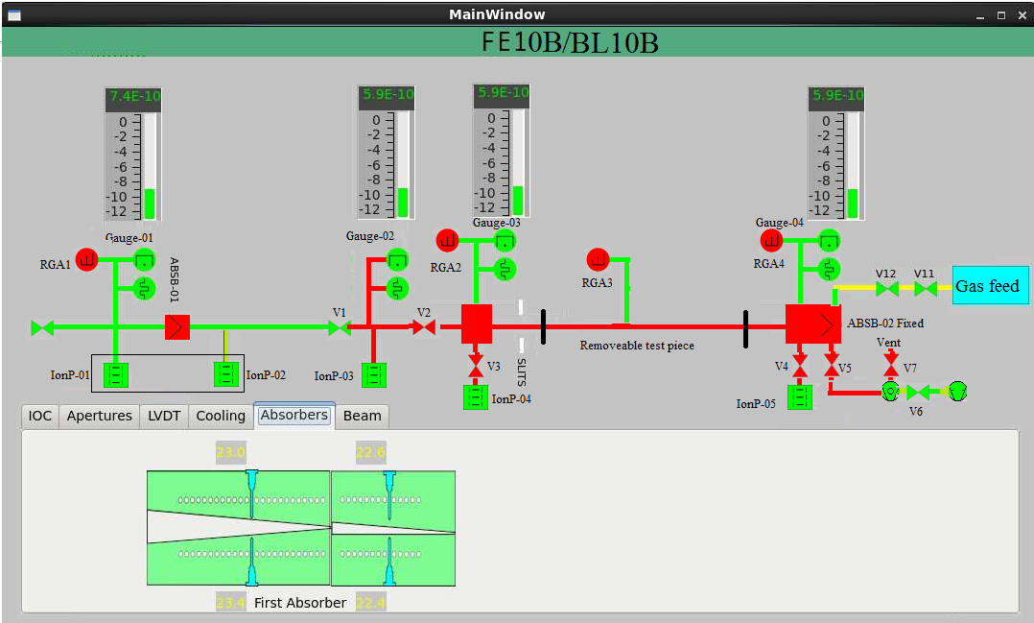

## Gas leak into vessel

It is planned to leak gasses into the test vessel to a pressure level slightly above double that of base pressure. This can be realised through a gas leak system, which contains a sample vessel of 50cc of 10bar of test gas leaked through a VAT motor controlled leak valve. A pneumatic shut off valve will behind the leak valve to limit the leak in case of a failure. This pneumatic valve will close if the pressure in the test vessel exceeds MPS2 setpoint of BL10B-VA-IMG-04 nominally set to 1 x 10-7 mbar.

## Test vessel bakeable

A permanent baking system from V2 to ABSB-02 will need has to be provided so that test chambers can be baked in situ. Two off zero volt contacts to be provided to the FE area from the valve crate to control the bakeout with pressure.

## Service mode Operation

In service operation, i.e. when the valve control crate is switched to service mode the valves will be controlled by PIRGS on either side of valves. It will not be possible however to open valves between sectors set to different modes

# Input Output Controller

The IOC will consist of a 1U high rack-mounted computer with I/O modules connected via the EtherCAT protocol link. Analogue inputs are 16 bits for ±10V and the serial communications is routed via a terminal server rather than to the IOC.

# Control Devices

For the frontend using the Diamond naming convention [1] the following parameters is identified.

|  |  |  |  |
| --- | --- | --- | --- |
| **Cell Gauges** | **Cell Ion Pumps/Size and Mechanical pumps** | **Standard Valves/absorbers** | **24 volt solenoids only**  **& leak valve** |
|  |  |  |  |
| FE10B-VA-PIRG-01 | FE10B-VA-IONP-01/500 | FE10B-VA-ABSB-01 | FE10B-VA-VALVE-06 |
| FE10B-VA-PIRG-02 | FE10B-VA-IONP-02/150 | FE10B-VA-VALVE-01 | FE10B-VA-VALVE-07 |
| FE10B-VA-PIRG-03 | FE10B-VA-IONP-03/500 | FE10B-VA-VALVE-02 | FE10B-VA-VALVE-12 |
| FE10B-VA-PIRG-04 | FE10B-VA-IONP-04/500 | FE10B-VA-VALVE-03 | FE10B-VA-VALVE-11 |
| FE10B-VA-IMG-01 | FE10B-VA-IONP-05/500 | FE10B-VA-VALVE-04 |  |
| FE10B-VA-IMG-02 | FE10B-VA-Roots-01 | FE10B-VA-VALVE-05 |  |
| FE10B-VA-IMG-03 | FE10B-VA-Turbo-01 |  |  |
| FE10B-VA-IMG-04 |  |  |  |
|  |  |  |  |

|  |  |  |  |
| --- | --- | --- | --- |
| **Component** | **Controller** | **Interlocked** | **Pump size** |
|  |  |  |  |
| **IonP-01** | MPC 1.1.1 | Gauge-01 | 500 |
| **IonP-02** | MPC 1.1.2 | Gauge-01 | 150 |
| **IonP-03** | MPC 1.2 | Gauge-02 | 500 |
| **IonP-04** | MPC 2.1 | V3closed/G3 | 500 |
| **IonP-05** | MPC 2.2 | V4Closed/G4 | 500 |
| **Gauge-01** | GCTRL1/A&C1 |  | N/A |
| **Gauge-02** | GCTRL2/A&C1 |  | N/A |
| **Gauge-03** | GCTRL1/B&C2 |  | N/A |
| **Gauge-04** | GCTRL2/B&C2 |  | N/A |

# EPICS Applications

The specification for EPICS applications for interfacing with the valve controllers, gauges and pumps are detailed in document TDI-VAC-CTRL-001

# Reference

[1] CTRL-XX-rpt-010 Proposal for a DIAMOND Control System Naming Convention

[3] TDI-VAC-CTRL-004–RGA

|  |
| --- |
|  |

# valve Logic

|  |  |  |  |  |  |  |  |  |
| --- | --- | --- | --- | --- | --- | --- | --- | --- |
| **Bit\valve** | **FE signal** | **V1** | **V2** | **V3** | **V4** | **V5** | **ABSB-01** | **Gauges** |
|  |  |  |  |  |  |  |  |  |
| 0 | All FE Gauges/V1 closed | Air press. OK | Air press. OK | Air press. OK | Air press. OK | Air press. OK | Air pressure | IMG-01 |
| 1 | IMG 1 & IonP I/L1 | IMG-01/V1 open&Absb not closed | IMG-02/V2 open&Absb not closed | IMG-03/V3 Open | IMG-04/V4 open | V6 open | FE Init Vac (4of 4) | IonP-01&2 I/L 2 |
| 2 |  | IMG-02/V1 open&Absb not closed | IMG-03/V2 open&Absb not closed |  |  | V2 closed | IonP-01 I/L2 | IMG-02 |
| 3 |  | IMG-01 or IonP-1&2 I/L2 |  |  |  |  | IonP-02 I/L2 | IonP-03 I/L 2 |
| 4 |  | IMG-02 or IonP-03 I/L 2 |  |  |  |  | Water flow ABSB-02 | IMG-03 |
| 5 |  | V5 closed |  |  |  |  | V1 not open | IonP-04 I/L 2 |
| 6 |  |  |  |  |  |  | V2 not open | IMG-04 |
| 7 |  |  |  |  |  |  | No V1 Close command | IonP-05 I/L 2 |
| 8 |  |  |  |  |  |  | No V2 Close command |  |
| 9 |  |  |  |  |  |  |  |  |
| 10 |  |  |  |  |  |  |  |  |
| 11 |  |  |  |  |  |  |  |  |
| 12 |  |  |  |  |  |  |  |  |
| 13 |  |  |  |  |  |  |  |  |
| 14 |  |  |  |  |  |  |  |  |
| 15 |  | Valve movement | Valve movement | Valve movement | Valve movement | Valve movement | Valve movement |  |
|  |  |  |  |  |  |  |  |  |

|  |  |  |  |
| --- | --- | --- | --- |
| **Bit\valve** | **V12** | **V11** | **V6** |
|  |  |  |  |
| 0 | Valve-11 Open | IMG-04 MPS2 | Scroll-01 on |
| 1 | V12 OK/Closed | V12 Clsd or V11 open |  |
| 2 | V12 Ready | IMG-03 MPS 2 |  |
| 3 | IMG-04 MPS2 |  |  |
| 4 | PIRG-04 |  |  |
| 5 | IMG-03 MPS2 |  |  |
| 6 |  |  |  |
| 7 |  |  |  |
| 8 |  |  |  |
| 9 |  |  |  |
| 10 |  |  |  |
| 11 |  |  |  |
| 12 |  |  |  |
| 13 |  |  |  |
| 14 |  |  |  |
| 15 |  | Valve movement | Valve movement |

|  |  |  |
| --- | --- | --- |
| **Bit\valve** | **Turbo Pump Interlock** | **Roots Pump interlock** |
|  |  |  |
| 0 | Roots on |  |
| 1 | V6 open |  |
| 2 |  |  |
| 3 |  |  |
| 4 |  |  |
| 5 |  |  |
| 6 |  |  |
| 7 |  |  |
| 8 |  |  |
| 9 |  |  |
| 10 |  |  |
| 11 |  |  |
| 12 |  |  |
| 13 |  |  |
| 14 |  |  |
| 15 |  |  |